Feynman Toy Theory
Modern Physics

Feynman’s Golden Rule for Decays
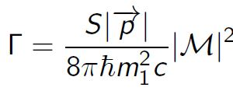
Recipe to find the amplitude:
- Notation: label the incoming and outcoming external vectors as four-momentum $p_{1},p_{2},⋯,p_{n}$ with an arrow to keep track of positive direction (forward in time = positive). For the internal momenta, label them as $q_{i}$ (direction is arbitrary).
- Vertex factors: For each vertex, write down a factor of -ig, where g is the coupling constant specifying the strength of interactions.
- Propagators: For each internal line, write down a factor of $\frac{i}{q_{j}^{2}-m_{j}^{2}c^{2}} .$
- Conservation of energy and momentum: For each vertex, write down a factor of ${\left(2π\right)}^{4}δ^{4}(k_{1}+k_{2}+k_{3})$ where the k values are the four-momenta coming into the vertex. If the momentum leads out, make it a negative sign.
- For each internal line, write down a factor of $\frac{1}{\{{\left(2π\right)}^{4}}d^{4}q_{j}$ and an integral.
- The result has a delta function ${\left(2π\right)}^{4}δ^{4}(p_{1}+p_{2}+⋯-p_{n}).$ Delete it and multiply the result by i. You've found the amplitude!
Example.
